**HTML5 lab1**

1. **Implement the given form and apply validation of its field via new HTML5 markups.**

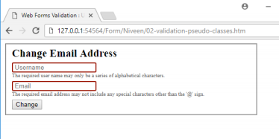

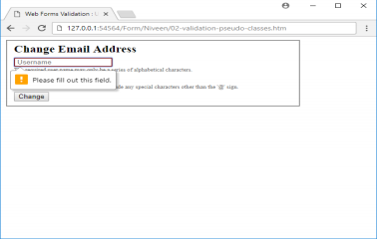

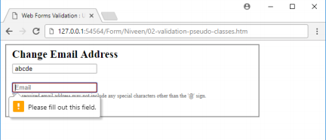

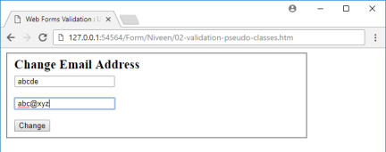

1. In the login form assignment, use local storage to save user name by add “remember me” check box, and save user name if the user checked this checkbox, and press login button, then retrieve it on page load and write it to the textbox.

and if the user didn’t check it, remove the saved user name local storage if they saved before

1. **. Text Color Range.** 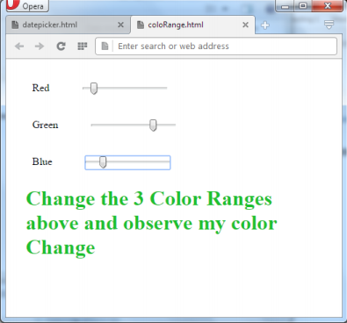

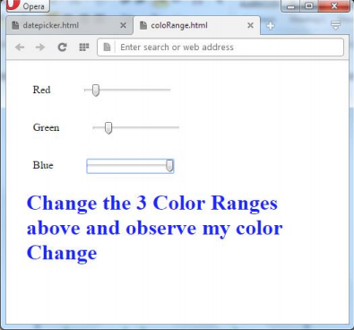

1. **Implement the functionality of audio controls and make your own media player**

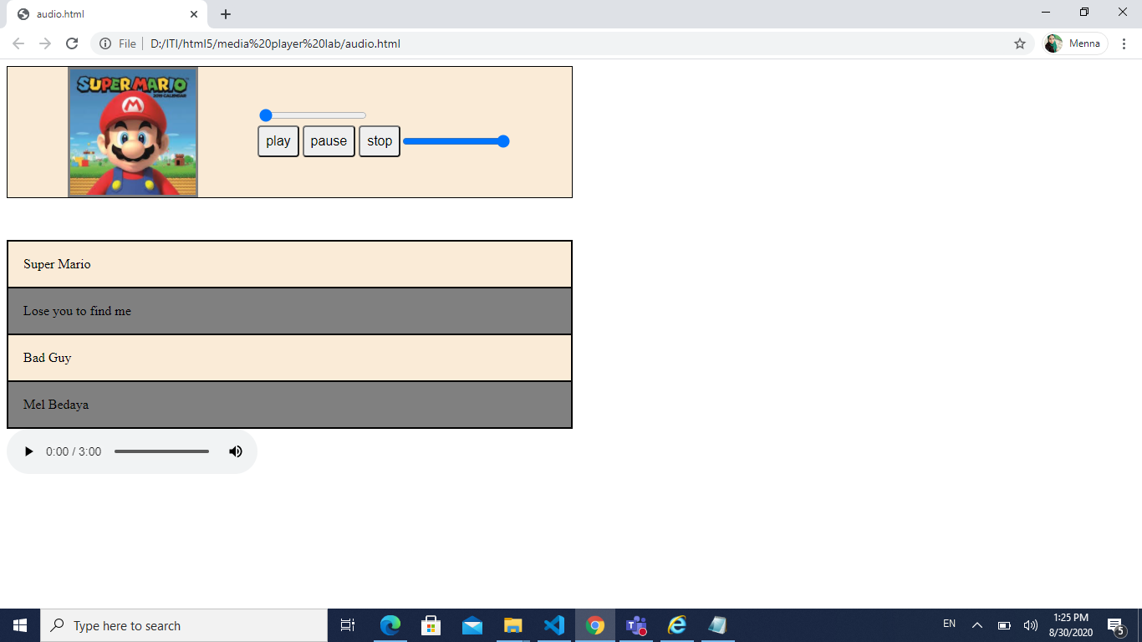

1. Make a page that’s displaying google map, and drop-down list containing countries, and when user select a country, change the google map to display this country.
   1. Make the google map when page loads display your current location with simple marker (use geolocation object).

<https://developers.google.com/maps/documentation/javascript/examples/marker-simple>